**HIGH_LEVEL DESIGN**

**ARCHITECTURE:**

**HOMEPAGE**

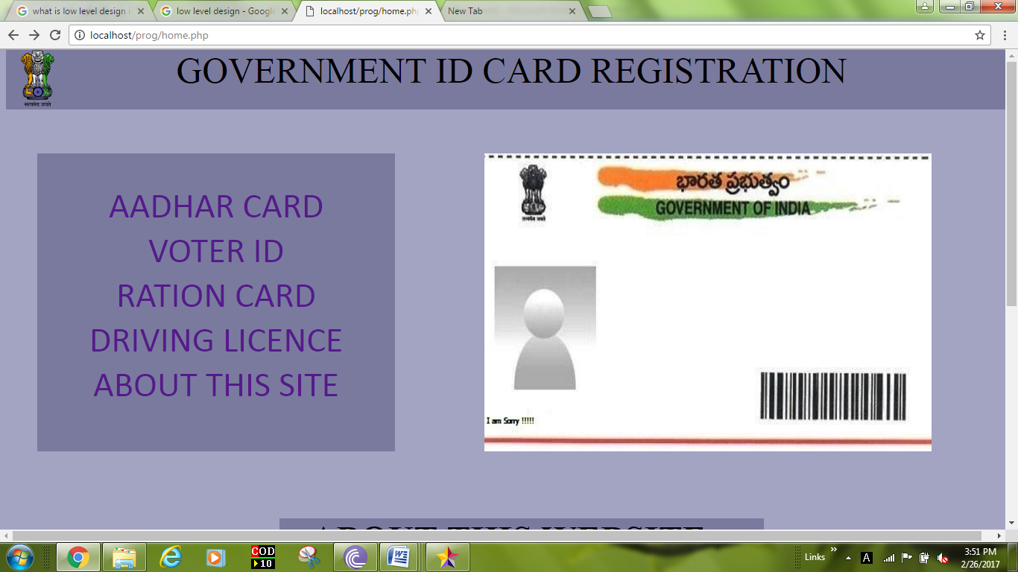

There are four types of government id card registration.

user can click on his/her wish option that he want to register new id card or track the registered card.

He can see about this website.

The colour is given violet to show unique. Four id card photo pictures are visible on right side of this page.

**REGISTRATION AND UPLOADING PROOF COPIES**

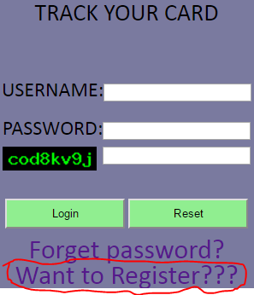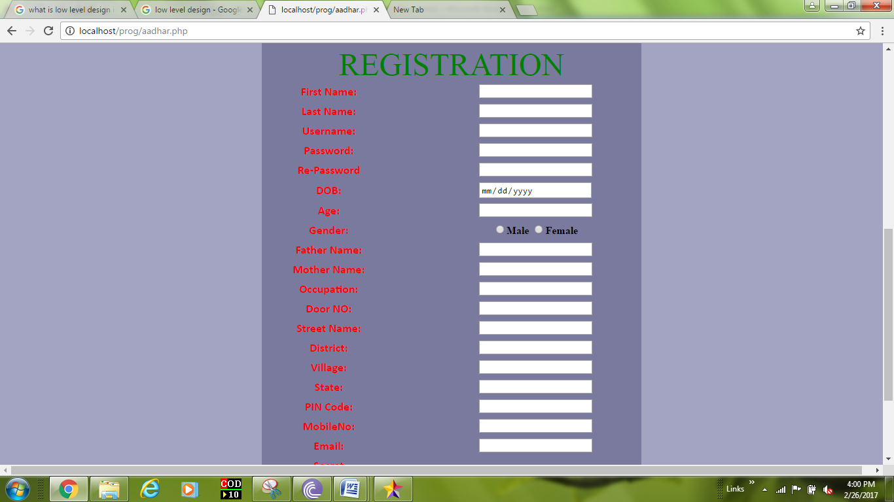

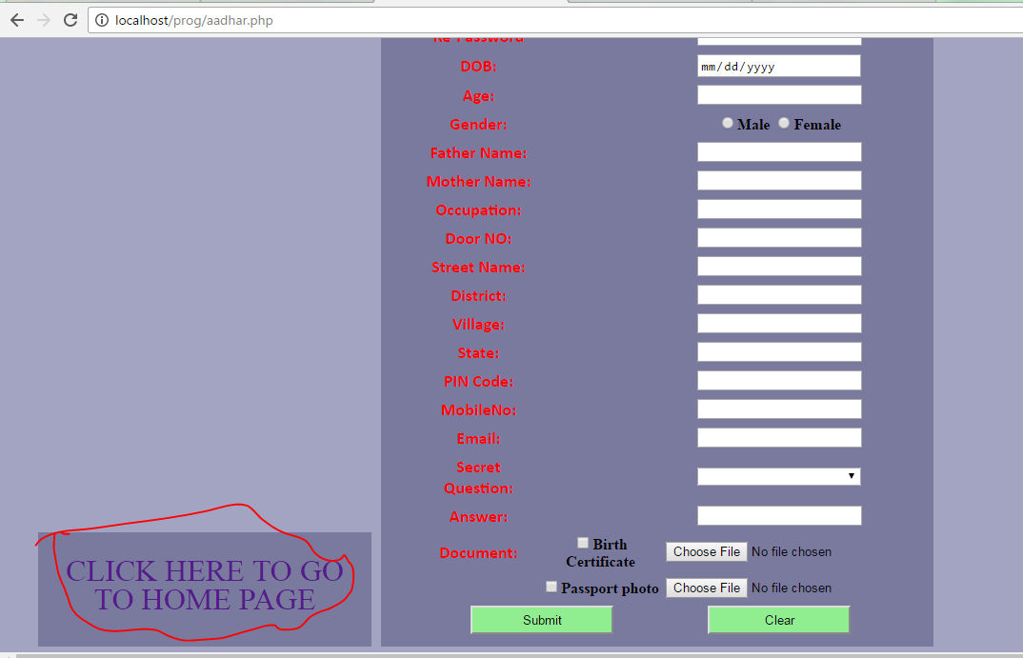

If user new to this website.

**By clicking** “want to register???” . colour is given blue.

He can register by filling the required details in displayed form for new id card and he can upload the required proof copies with that registration form.

He can submit it.

**By clicking on** “click here to go to homepage “on left side of registration form.

User cango to home page.

**TRACK REGISTERED ID CARD**

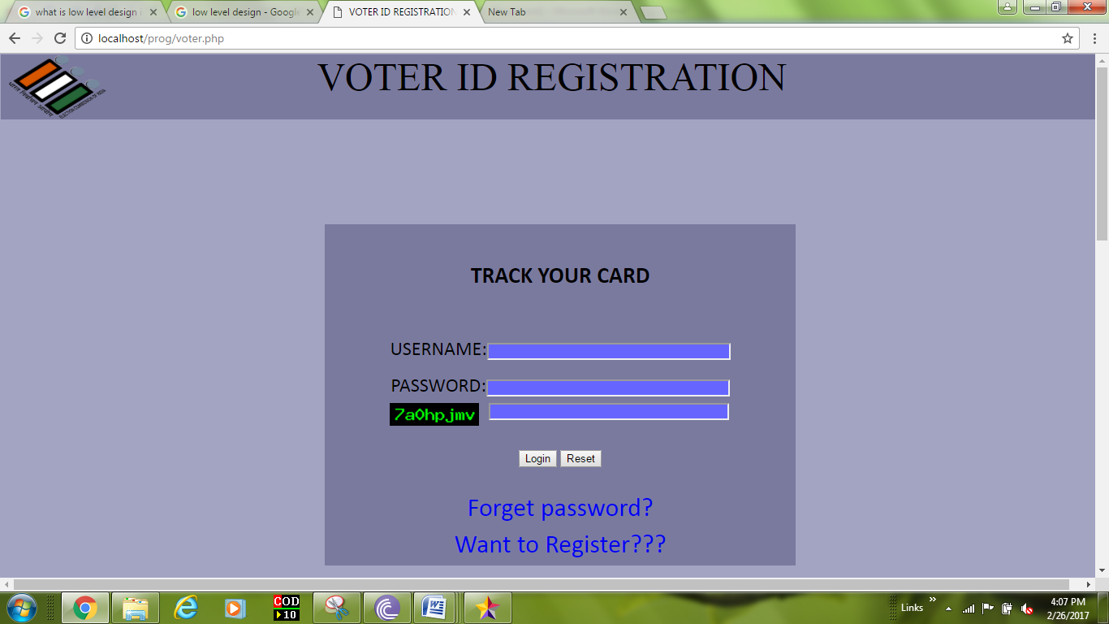

If he registered already for id card.

He can login by entering **registered** credentials.

He could **track** his id card status details.

**FORGOT PASSWORD**

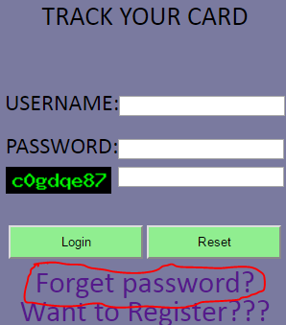

If user has forgotten his password .

He can **click** “forgot password?” colour is given violet.

He can login by entering registered credentials.

Registered id card status will be shown after successful login

**DATABASE SYSTEM:**

In this system, we are used mysql databases for id card registrations and tracking the Id cards. The registered user details have secured. We are doing operations such as creating, updating ,retrieving and deleting information details on databases. This registration website designed using php, html, CSS . And also worked on java platform. Admin can be operating the system databases. He will made updating the changes.

